Assignment 2 – Arrays
- Merge two sorted arrays
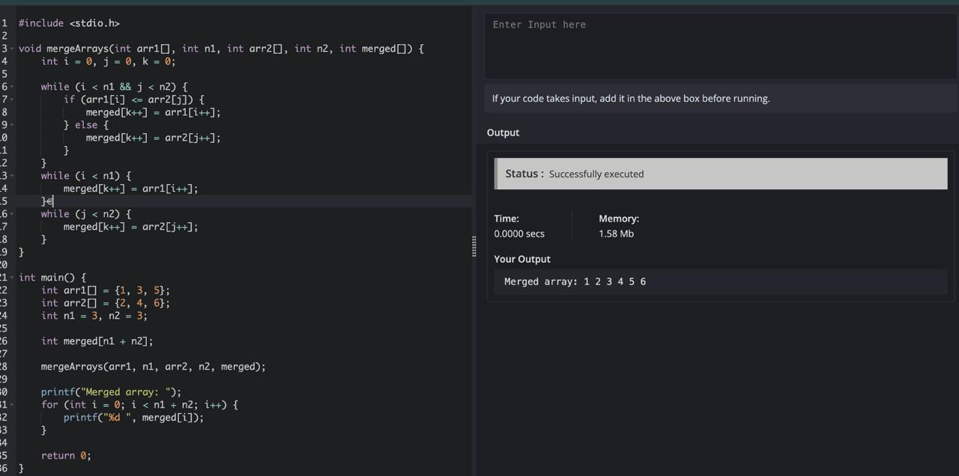

- Delete a given element in an array

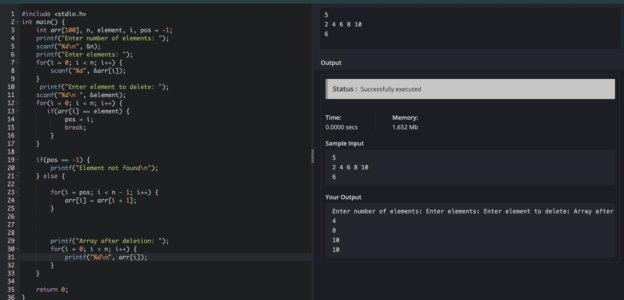

- Insert an element in the desired index in an array

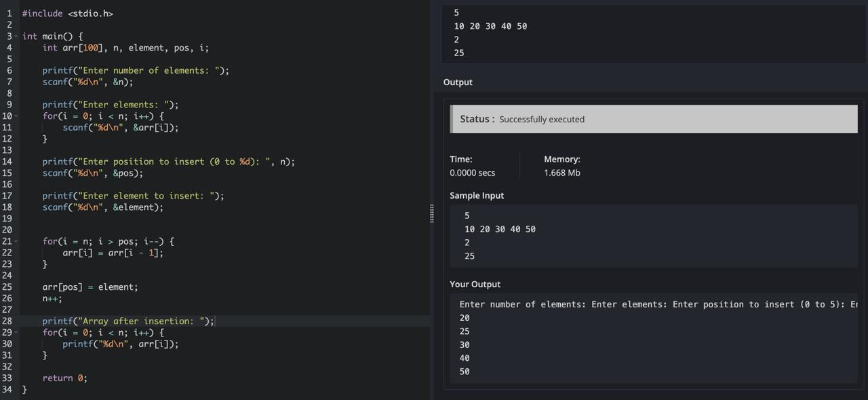

- ​Write a program to find the number of composite numbers in an array of elements Sample Input;:
Array of elements = {16, 18, 27, 16, 23, 21, 19} Sample Output:
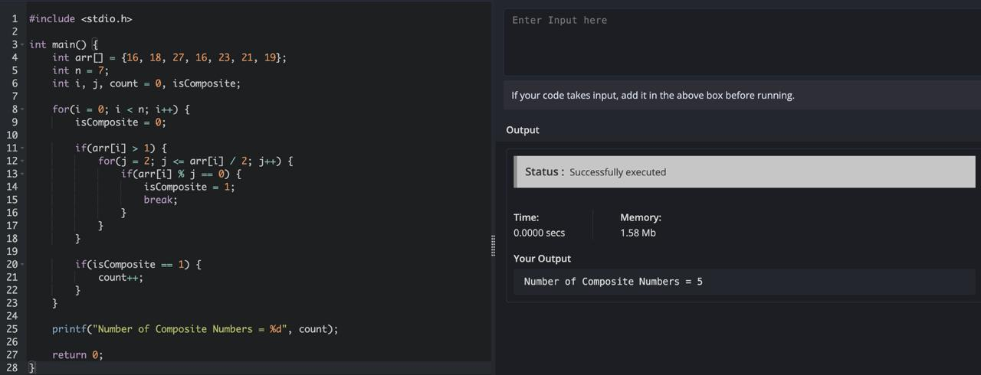
Number of Composite Numbers = 5

- Write a program to print the number of negative numbers in an array of numbers Sample Input;
Array of elements = {16, -18, 27, -16, 23, -21, 19} Sample Output:
Number of negative numbers in Array elements = 3

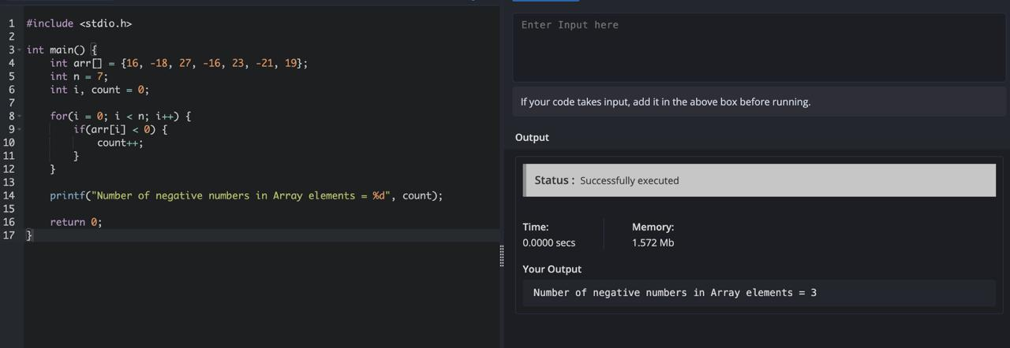

- Write a program to reverse an array Sample Input;
Array of elements = {16, 18, 27, 16, 23, 21, 19} Sample Output:
Reverse Array elements = {19, 21 23, 16, 27, 18, 16}

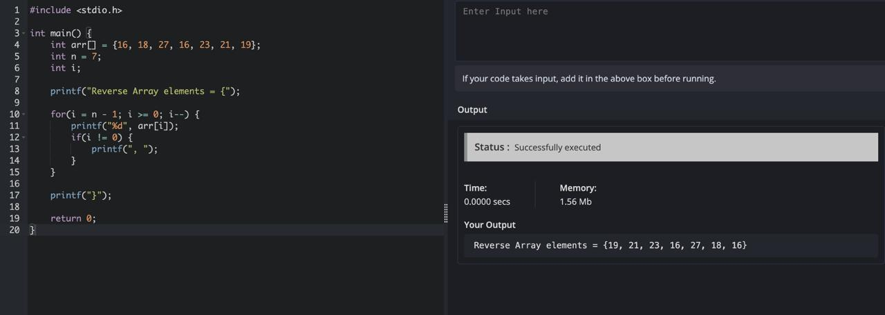

- Write a program to search the given element and display its position in a linear array. Sample Input;:
Array of elements = {16, 18, 27, 16, 23, 21, 19} Element to search = 23
Sample Output:
Given element 23 is found at 5 th position

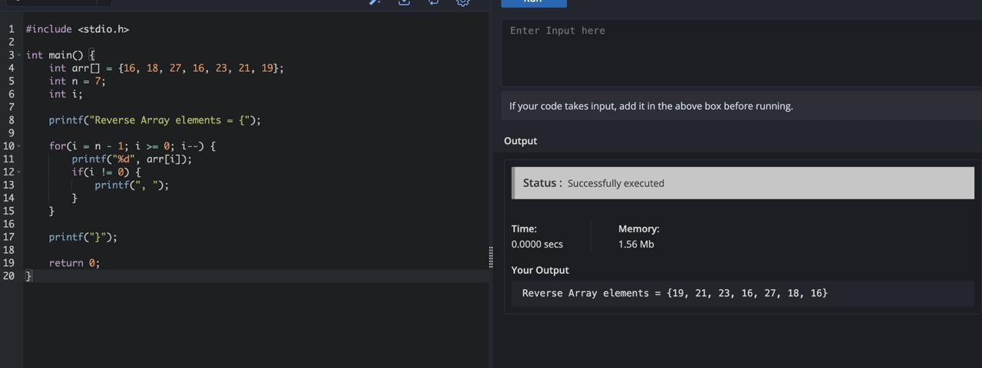

- Program to remove duplicates from the sorted array Sample Input:
Array = {15, 14, 25, 14, 32, 14, 31}
Sample Output:
Removed Array = {14, 15, 25, 31, 32}

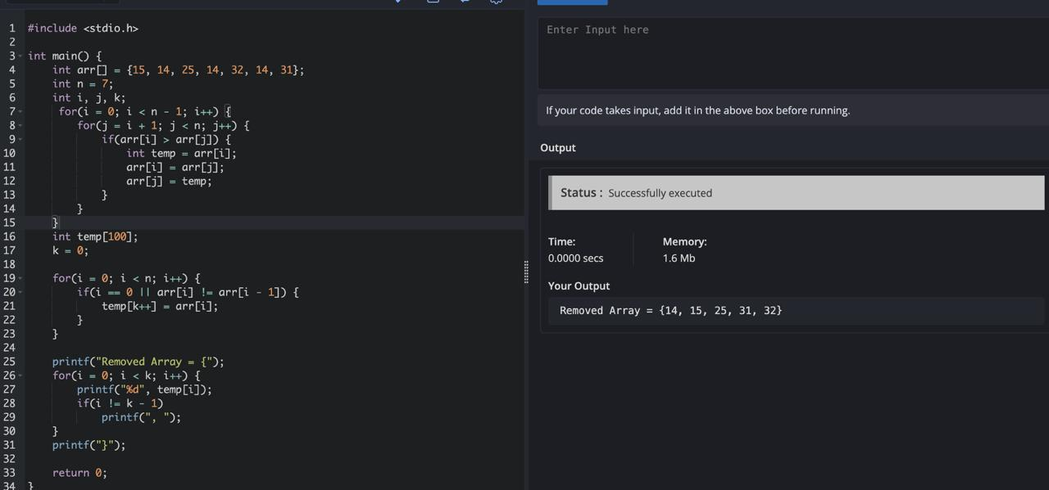

- Write a Program to find the sum and average of numbers in a matrix format of array

Sample input:
1 2 3
4 5 6
7 8 9

Output:
Sum = 45
Average = 5

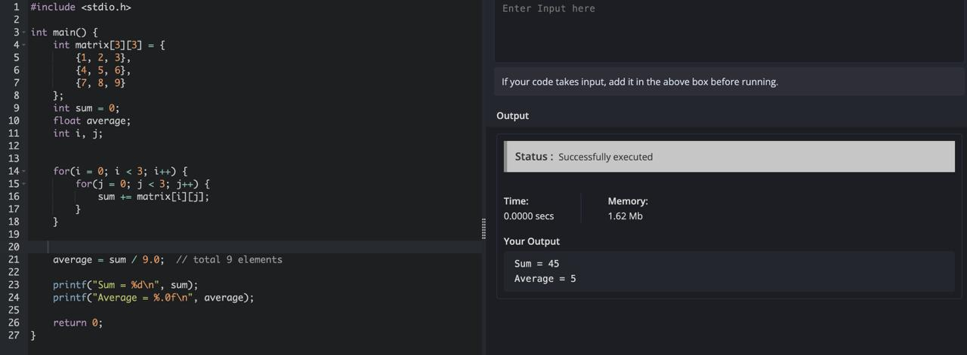

- Write a program for matrix Multiplication? Sample Input:
Mat1 = 1 | 2
5 | 3
Mat2 = 2 | 3
4 | 11
Sample Output:
Mat Mul = 10 25
22 48

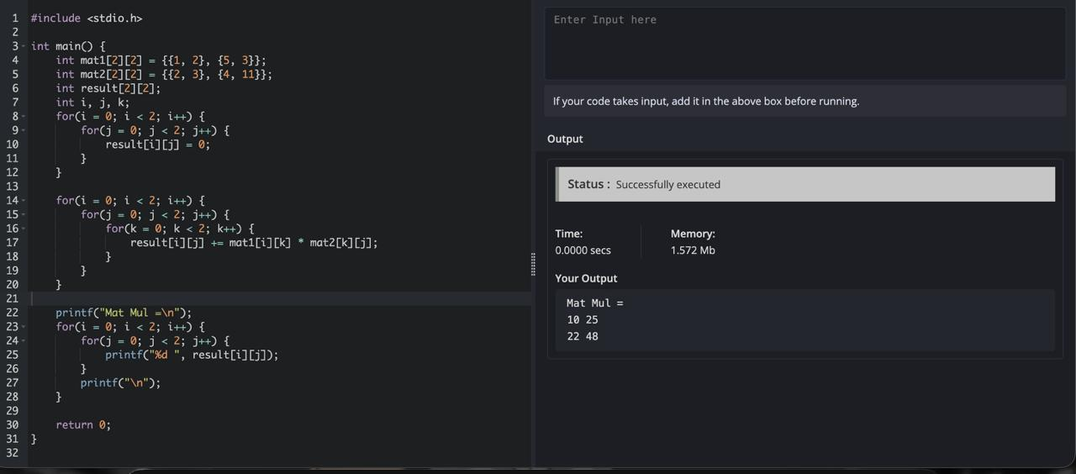
- The transpose of a matrix is found by interchanging its rows into columns or columns into rows. Write a program to find the Transpose of a given Matrix.
Sample input:
1 2
5 3
Output:
1 5
2 3
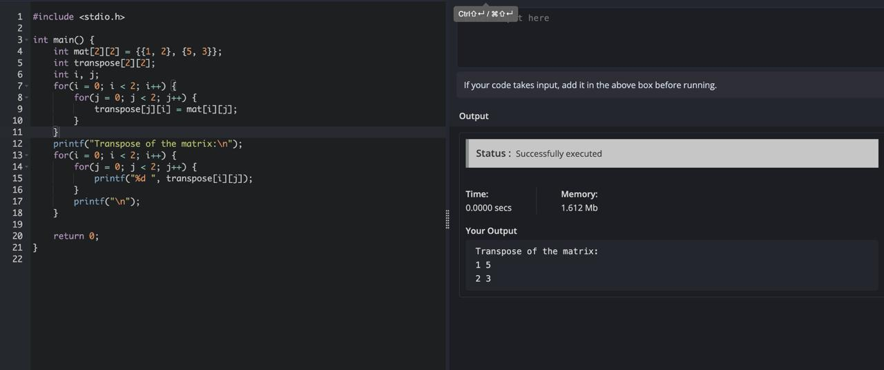

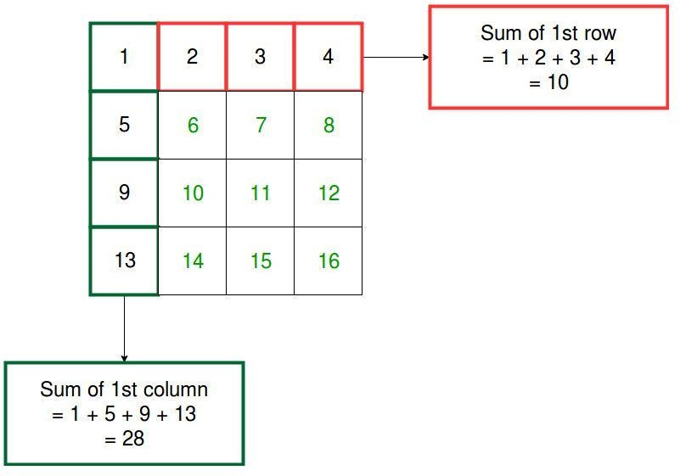
- Program to find the Sum of each Row and each Column of a Matri

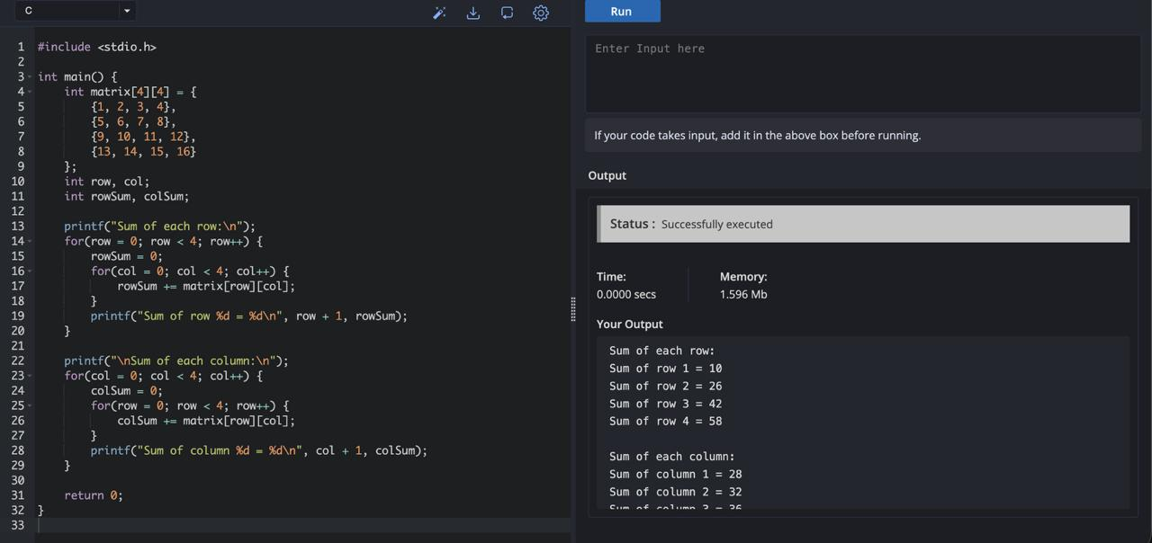

13.C Program for Program for array rotation- rotates array of size n by d elements.

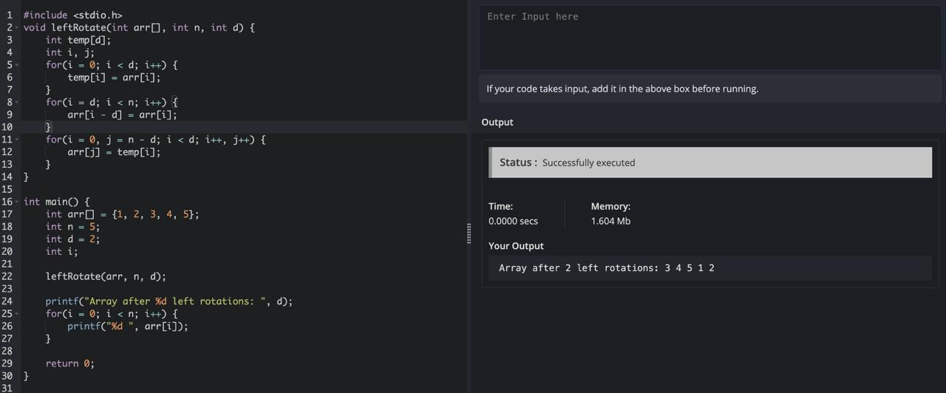

14.C Program for Second min element in an array

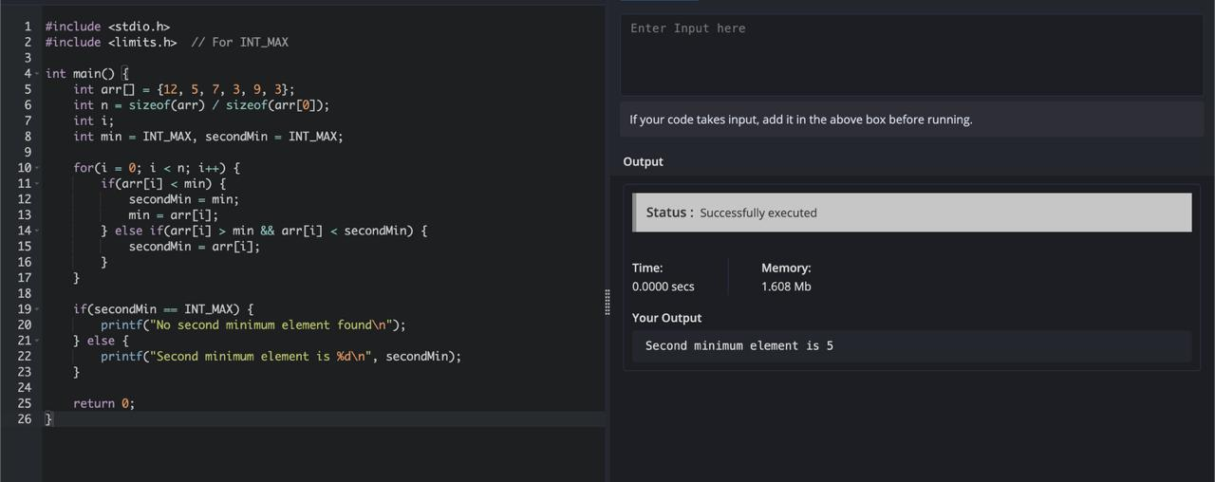

15.C Program for Kth min in an array



